Worms and Lettuce
First Grade
Summer Fagan
This Garden Project Based Learning unit has two modules: A Worm’s Life( completed in the fall) and Lettuce Teach you (completed in winter-spring).
North Elementary School Affiliation
Origin of These Units. These Garden Project-Based Learning (GPBL) units originate from instruction that North Elementary School (Morgantown, WV) teachers began providing to students in the Spring of 2011. We launched our school gardening efforts through a “Lowe’s Toolbox for Education” grant and in partnership with the College of Education and Human Services at West Virginia University, Monongalia County Extension Office, Monongalia Technical Education Center, and parents of our students.
When and Where it Happens. In all of these units, GPBL takes place inside (the indoor classroom) and outside (the school garden area “outdoor” classroom). Indoors, students learn through the use of grow lights, heat mats, seed germination and growing containers (e.g., EarthBox®), and vermicomposting bins. Instruction is extended to the outdoors through the use of raised garden beds, in which students directly sow seeds and transplant classroom seedlings (see http://www.thevegetablegarden.info/planting-schedules for USDA growing zones). Students also use low tunnels over the raised beds in order to extend the growing season and protect crops from pests. With permission, garden produce may also be served as part of the school lunch. Cafeteria fruit and vegetable clippings/refuse that is not served to the students can be composted and used to amend the garden soil. Learning can continue throughout summer vacation, where students assist their parents who volunteer to take care of the raised beds (watering, mulching, weeding, trellising, etc.). Produce can be vended at a local farmer’s market.
What’s Essential. First and foremost: You need strong support from the principal, custodial and cafeteria staff, and parents as well as expert assistance from the local extension office, including volunteer master gardeners. Here are a few more essentials:
- Integrate GPBL with core curriculum/standards; do not make it an “add-on.” School gardening is an excellent context for application of the Next Generation Science Standards “Science and Engineering” practices and Common Core Mathematics Practices
- Maintain a small library of gardening text and Internet resources.
- Share knowledge and collaborate on projects.
- Install a fence around and a supply shed close to the outdoor garden; have a close-by water supply, > 6 hours sunlight, and high quality soil (consult County Extension).

- Take safety precautions such as:
  - know what students are allergic to (including bees) and avoid contact; a bee sting to a person with severe allergy (anaphylaxis) requires immediate medication (usually injection of epinephrine) and medical attention (emergency room);
  - wash hands after any gardening activity and keep a first aid kit handy;
  - always install tube covers over fluorescent grow lights;
  - keep water away from electrical outlets/avoid shock hazards;
  - don’t use “chemical” pesticides;
  - use plastic versus glass containers and wear goggles when eye damage may occur
  - supervise students and provide instructions on the use of garden tools (young learners should not use “adult-size” shovels and hoes).

Supplies Commonly Used In Units. (Identification of any product does NOT constitute endorsement).
- Seeds (not treated) or Bare Roots (for strawberries and certain flowers)
- Pots or Sheets of Cells (in which to germinate seeds) and Trays (in which to hold pots)
- Seed Germination Heat Mat
- Craft Sticks for Marking Type/Locations of seeds/transplants
- Grow Lights (e.g., Hydrofarm® T5 Growlight System or cart with lights and place for seed trays)
- Tube Covers/Protectors (you MUST install tube covers over any fluorescent lights)
- Timers (to automatically turn on and off grow lights)
- Containers/kits for Indoor Gardening (e.g., EarthBox®)
- Low Tunnel (you generally need to make these yourself using greenhouse film and bendable hoops, such as PVC pipe or wire that is secured into the ground or in a wooden frame)
- Potting Soil (WonderSoil® or other suitable products also can be used). Note: Soil for planting should be moist enough to form a clump but not gush water when squeezed).
- Measurement Tools (e.g., rulers, moisture/temperature gauges, scale, graduated cylinder/beakers
- Mulch (e.g., partially composted leaves, organic straw, NOT grass from “treated” lawns)
- Wood/frames (NOT treated) and suitable topsoil (check with County Extension) for raised beds
- Horticultural fleece (garden fleece, Agribon®, Reemay®) for insect barrier and frost protection
- Garden Tools (e.g., trowel, shovel, hoe, rake…a mattock for landscaping to install raised beds)
- Compost to Amend Soil (check with County Extension)
How These GPBL Units are Structured. The graphic on the next page illustrates the components of a GPBL unit as well as how these components are interrelated. For units that require the care of garden plants in summer: Students must prepare a caretakers’ guide. They also write a persuasive letter to parents inviting them to a presentation about the garden and to be caretakers (along with their children) during the summer. Development of the guide, letter, and presentation are excellent ways to integrate English/language arts and art as well as apply the science that they have learned throughout their GPBL.

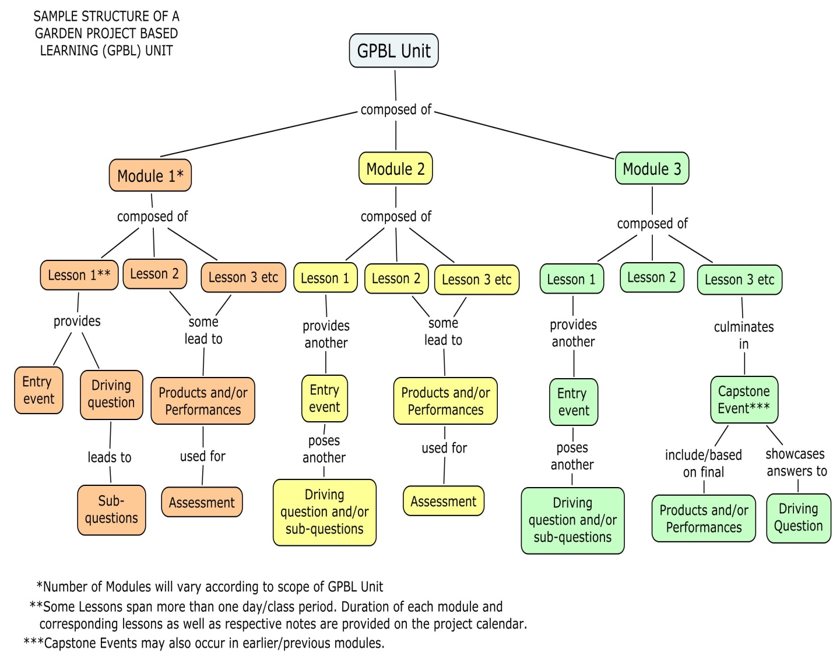

Project Summary
This Garden Project Based Learning unit has two modules: A Worm’s Life( completed in the fall) and Lettuce Teach you (completed in winter-spring).
As a class start and care for a worm bin. Experience which fruits or vegetables the worms decompose the quickest. Later we will use the worm soil to plant lettuce and compare which type of soil is the most successful.
This project will incorporate math, science, and reading language arts. Students will engage in activities such as caring for and feeding the worms, planting lettuce from the seed and watching it grow.
The goal for this project will be to grow enough lettuce to feed the students in the cafeteria.

Project Driving Question(s)
Which fruits/vegetables will worms decompose the fastest?
What do worms like to eat?
Which soil will grow the best vegetables?
What is the best type of lettuce to grow in our garden to serve in the cafeteria?

Major Products & Performances in Unit
-Graph of food and days it took to decompose
-Garden journals
-Poster of worm food
-Story about a worm
-Worm songs
-Lettuce Powerpoint
-Graph of favorite types of lettuce
-Lettuce garden (planting and caring for)
-Lettuce served in the cafeteria
-Worm caretaking (maintain a worm bin)

Resources Needed for Unit

Bruel, R. (1997) “Bob and Otto” Roaring Brook Press
French, V. (2010) “Yucky Worms” Candlewick
Cronin, D. (2003) “Diary of a Worm” HarperCollins
Lionni, L. (1995) “Inch by Inch” HarperCollins
Caple, K. (2000) “Worm is Hot” Candlewick Pr
Caple, K. (2000) “Worm Paints” Candlewick Pr
Caple, K. (2000) “Worm Smells” Candlewick Pr
Caple, K. (2000) “Worm Builds” Candlewick Pr
Caple, K. (2000) “Worm Watches” Candlewick Pr
Caple, K. (2000) “Just Right” Candlewick Pr
Schuh, M. (2011) “Lettuce Grows on the Ground” Pebble Books
Salas, L. (2008) “Lettuce Introduce You : Poems About Food.” A+ Books

www.envirochallenger.com

http://www.stemmom.org/2012/10/can-worms-smell-wormy-experiment.html#comment-form

http://www.wormfarmingrevealed.com/fun-facts.html

United Streaming clip “Farming and Agriculture: Plant Parts We Eat: Leaves and Flowers” http://app.discoveryeducation.com/search?Ntt=lettuce

References Used in Developing Unit
Enviro Challenger www.envirochallenger.com

Stem Mom Can Worms Smell? http://www.stemmom.org/2012/10/can-worms-smell-wormy-experiment.html#comment-form

Fun Facts about Worms http://www.wormfarmingrevealed.com/fun-facts.html

